**CONCLUSIONS AND RECOMMENDATIONS**

After performing the requested executions, we had to make an analysis of the results.

One thing that should be taken into account by its great importance, is that at the time of the executions a problem where the server rejects Pivotal Tracker showing many requests had the following error:

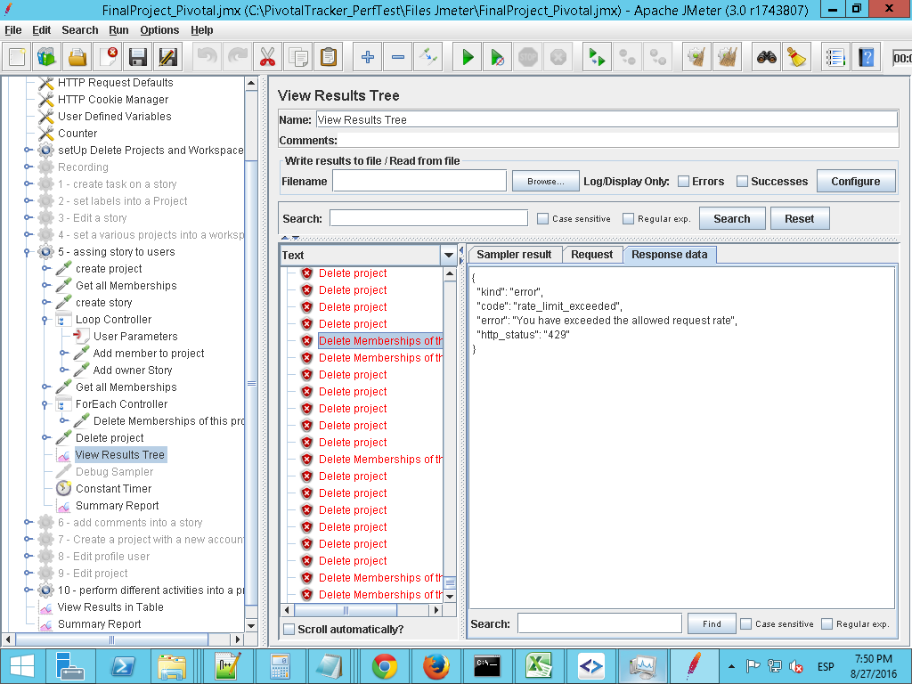

This is due to the large number of sent and applied in a short time requests.

**ANALYSIS OF RESULTS**

**Conclusion:** The graphic shows expected results, as the number of requests is rising according to increase of users

**Recommendations:** Non

**Conclusion:** You can see the rising time between the first and second execution. An expected result because the amount of requests made with different numbers of users .

**Recommendations:** It is recommended to repeat executions with longer waiting times for other results

**Conclusion**: you can see a flow enters the first and second execution that the number of bytes received is normal.

**Recommendations:** It is recommended to repeat executions with longer waiting times for other results.

**Conclusion**: Errors enters the second and third execution must be taken into account especially to repeat the execution and get real results.

**Recommendations**: It is recommended executions where the error rate is minimum to get real results.